**WEEK 9 – NO SQL Lab 1**

**(Tuesday, 17-01-2023)**

**Perform the following DB operations using MongoDB.**

* **Create a database “Student” with the following attributes**

**Rollno, age, contactNo, Email-Id.**

db.createCollection("Student");



* **Insert appropriate values**

db.Student.insert({rollno:1,age:21,cont:9876,email:"prannay@gmail.com"});

db.Student.insert({rollno:2,age:22,cont:9976,email:"sohan@gmail.com"});

db.Student.insert({rollno:3,age:21,cont:5576,email:"farhaan@gmail.com"});

db.Student.insert({rollno:4,age:20,cont:4476,email:"sakshi@gmail.com"});

db.Student.insert({rollno:5,age:23,cont:2276,email:"sanika@gmail.com"});

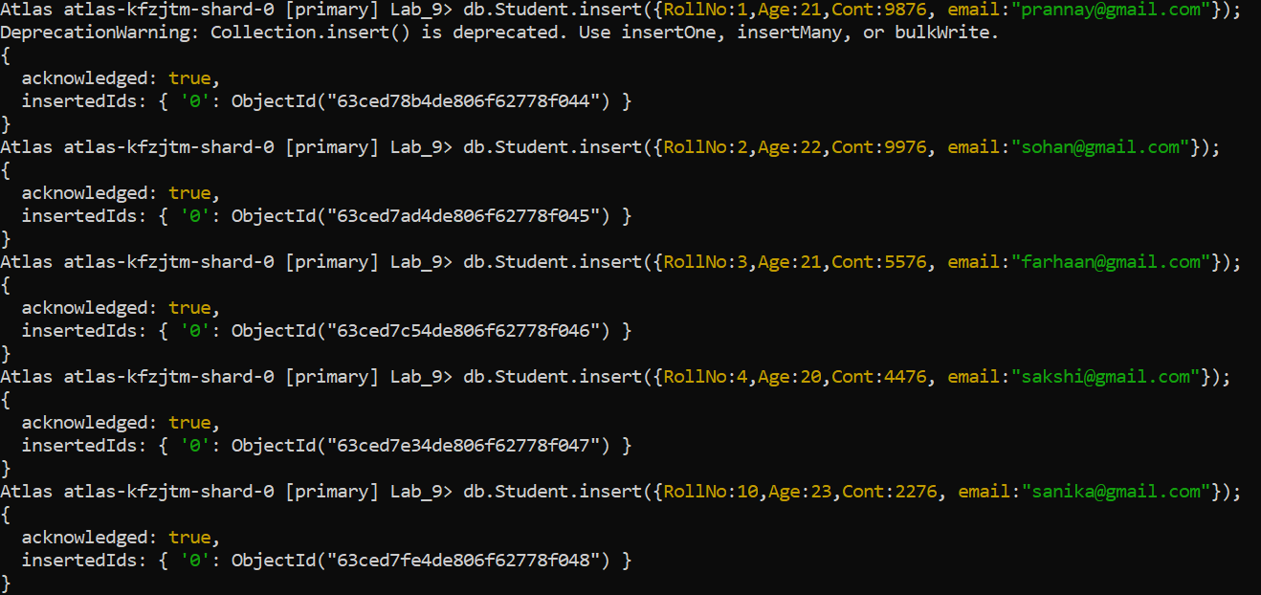

* **Write a query to update the Email-Id of a student with rollno 5.**

db.Student.update({rollno:5},{$set:{email:"abhinav@gmail.com"}})

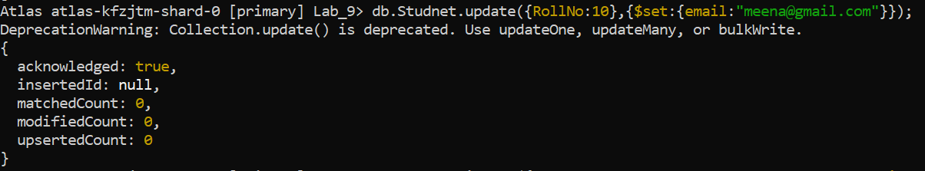

* **Replace the student name from “ABC” to “FEM” of rollno 11.**

db.Student.insert({rollno:11,age:22,name:"ABC",cont:2276,email:"madhura@gmail.com"});

db.Student.update({rollno:11,name:"ABC"},{$set:{name:"FEM"}})

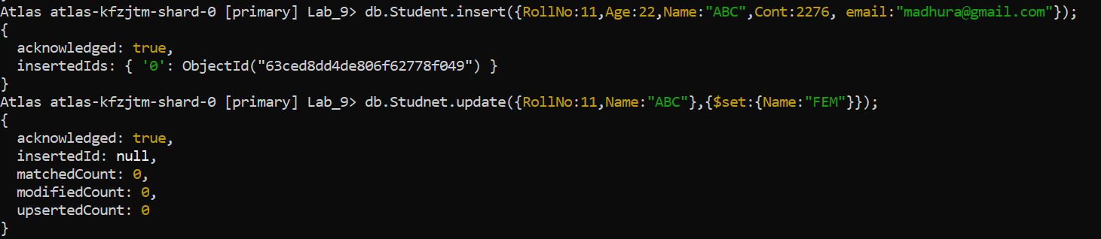

* **Export the created table into local file system**

mongoexport mongodb+srv://dhiksha:<password>@cluster0.xbmgopf.mongodb.net/Lab_9 --collection=Student -- out C:\Users\dhiks\Desktop\export\output.json

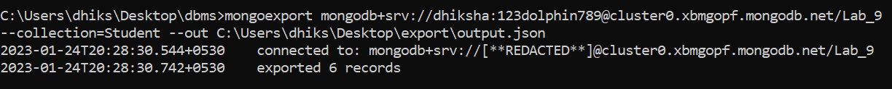

* **Drop the table**

db.Student.drop();

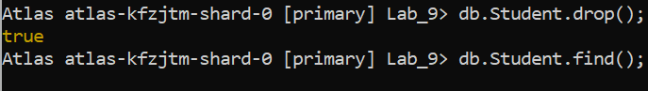

* **Import a given csv dataset from local file system into mongodb collection.**

mongoimport mongodb+srv://dhiksha:<password>@cluster0.xbmgopf.mongodb.net/Lab_9 --collection=new_Student – type json –file C:\Users\dhiks\Desktop\export\output.json

